Caitlyn Jones
Prof. Yangyang Wang
MATH 40A: Introduction to Applied Mathematics
12 September 2024
Lab 1
- The method def worldseries(p,N)function simulates a world series based on p, the probability that the best team will win, and N, the number of games in the world series; the method will return the final score of the world series as an ordered pair. To start, we must initialize two variables, win and lose, that tracks the winning team’s wins and losses.

Next, we will actually need to simulate game play by using a while loop that will stop executing when there is a clear winner, or when one team has won more than half of N. In the case of this problem, this loop will stop once either team wins 4 games. During the loop, to simulate the actual games, there will be the drawing of a random number between [0,1]. If the number drawn is less than p, then the winning team wins, and the variable win is incremented by 1. If the number is greater than p, then the losing team wins and lose is incremented by 1. Lastly, the function calls save_losses(x,y),with x being win and y being lose (I will go over this function in the next question). As stated earlier, the method returns win, lose as an ordered pair.
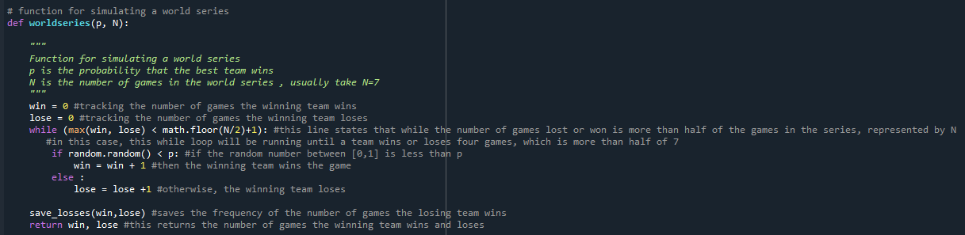
- To run this program 44 times, we must use a loop that will simulate a world series 44 times while saving the score each time. I created the method run_worldseries_loop_one() that will call the worldseries(p,N) method 44 times and print out the saved values from saved_losses(x,y) once the loop has ended.
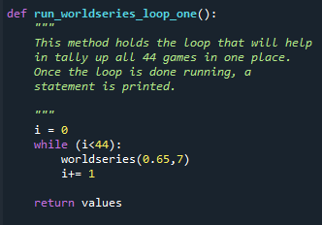

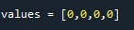
In order to count and graph the number of times the losing team wins 0,1,2, and 3 games, we need to save this data in a bar graph. My approach to this problem was to create a list variable, values = [0,0,0,0], with each value initialized to 0. This list will hold the total of 0 games won, 1 game, and so on.

Next, I updated values in save_losses(x,y) every time the winning team won the series by saving the frequency of the number of games won by the losing team in values.
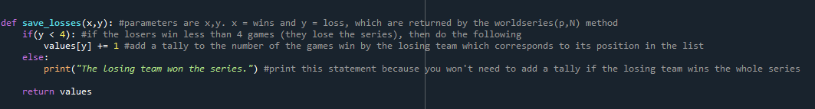

Finally, I ran the loop, which now saves the data of all 44 world series’ in one list, and plotted the data collected in a bar graph.
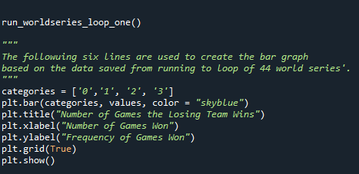

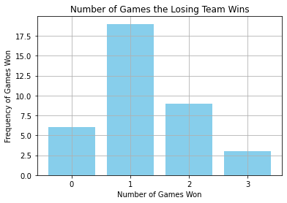

Compared to the paper, these results are similar. Both in the paper and on my graph, the losing team has the highest frequency of lost games at 1. However, in the paper the lowest frequency was at 0, but on my graph, the lowest frequency was at 3.

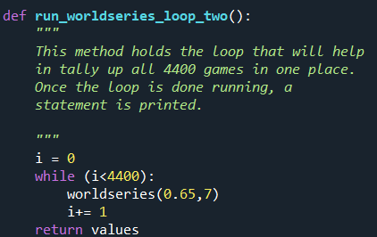
- To run the loop 4400, I simply created another method run_worldseries_loop_two() that will run worldseries(p,N) 4400 times.

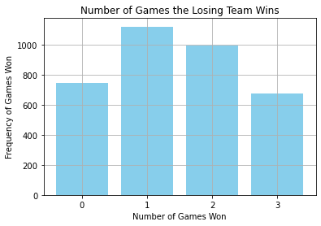

The fraction of games the losing team wins does not change significantly when more games are played. If anything, the values from the first graph are magnified in the second graph. Mosteller’s measurements for the first fifty years were accurate to the results of my graph, as the winning team won 31 out of 48 games.
- The function worldseries2 does the same actions as worldseries1 except a small change in worldseries(p,N). Instead of comparing a random number to p like we did in worldseries1, worldseries2 takes a different approach to make the simulation more real. They define the variable p_real, which holds p with a small perturbation. This comes from the result of multiplying the random number by 0.05 and adding it to p. This will result in p having small but noticeable fluctuations, which will simulate a more real-world example of random games.
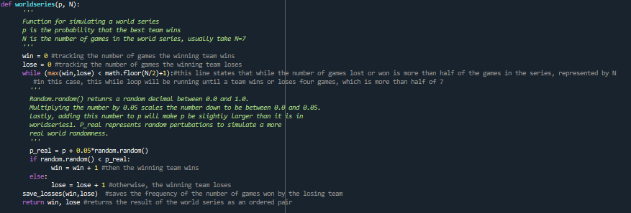
- In order to graph worldseries2, I follow the steps from part 2 and 3 to receive the following graphs:
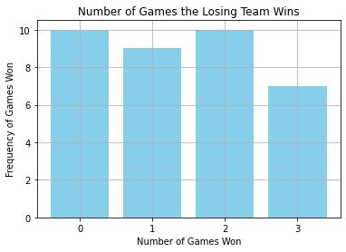
Loop ran 44 times:

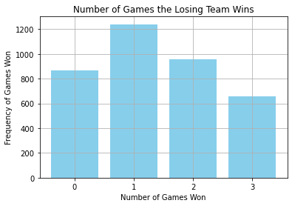
Loop ran 4400 times:

The results of worldseries2 are incredibly similar to the results in worldseries1. However, when running worldseries2 44 times, the frequency of the losing team one game was not the highest; in fact, the highest frequency of games won was a tie between 0 and 2.
- I am unhappy with Mosteller’s model because there is truly no way of predicting the random events that happen during baseball games, such as injuries, bad referees, and motivation of the team. There really isn’t a way to calculate these things, but it is something to think about when computing the probability of a “better” team winning.

